Document title

Documentation for the FSC Identikit

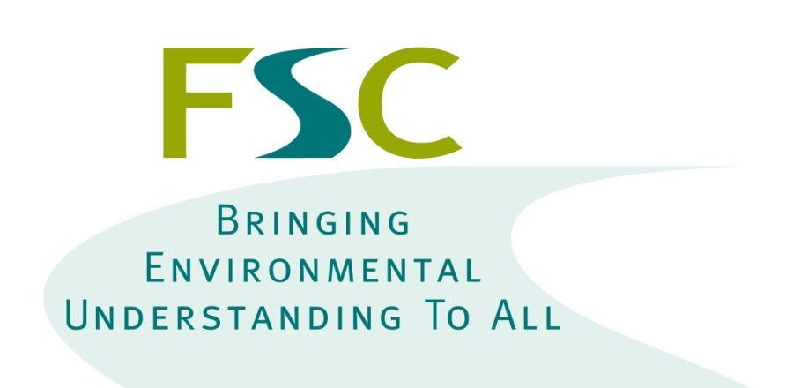

Dr Richard Burkmar  
BioLinks Digital Development Officer  
Field Studies Council  
Head Office  
Montford Bridge  
Shrewsbury  
SY4 1HW

[r.burkmar@field-studies-council.org](mailto:r.burkmar@field-studies-council.org)

Development funded by the Esmée Fairbairn Foundation and the Heritage Lottery Fund

# Contents

1 Contents 2

2 Introduction 3

# Introduction

xxx.